Problem 1:

The observed proportions of heads for a fair coin is always approximately 50% for experiments of flipping 50 times, 500 times and 5000 times. If each experiment is replicated for multiple times, we can observe that compared to flipping 50 times, the outcome of 5000 times is more constant, which means it fluctuates around 50% at a smaller margin. Same observations are observed for a coin with 57% probability for getting a heads, except for that the outcomes oscillate around 57% instead of 50%.

A snapshot of the R output:

# fair coin

50 times: 56%

500 times: 51%

5000 times: 50.2%

# unfair coin with probability of 57% getting heads

50 times: 70%

500 times: 60%

5000 times: 57.82%

After replicating the experiment of 50 flips 100 times, I observed most of the outcomes are around 25 heads (=50 * 50%):

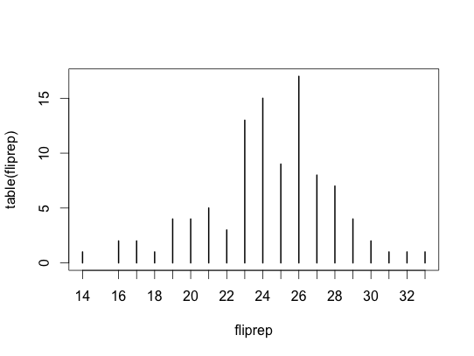

Problem 2:

a) P(r) = # of r/# of months = 0.667

b)P(r,L) = # of r intersect L / # of months = 0.333

c)P(r|L) = # of r intersect L / # of L = 0.571

d) Venn diagram

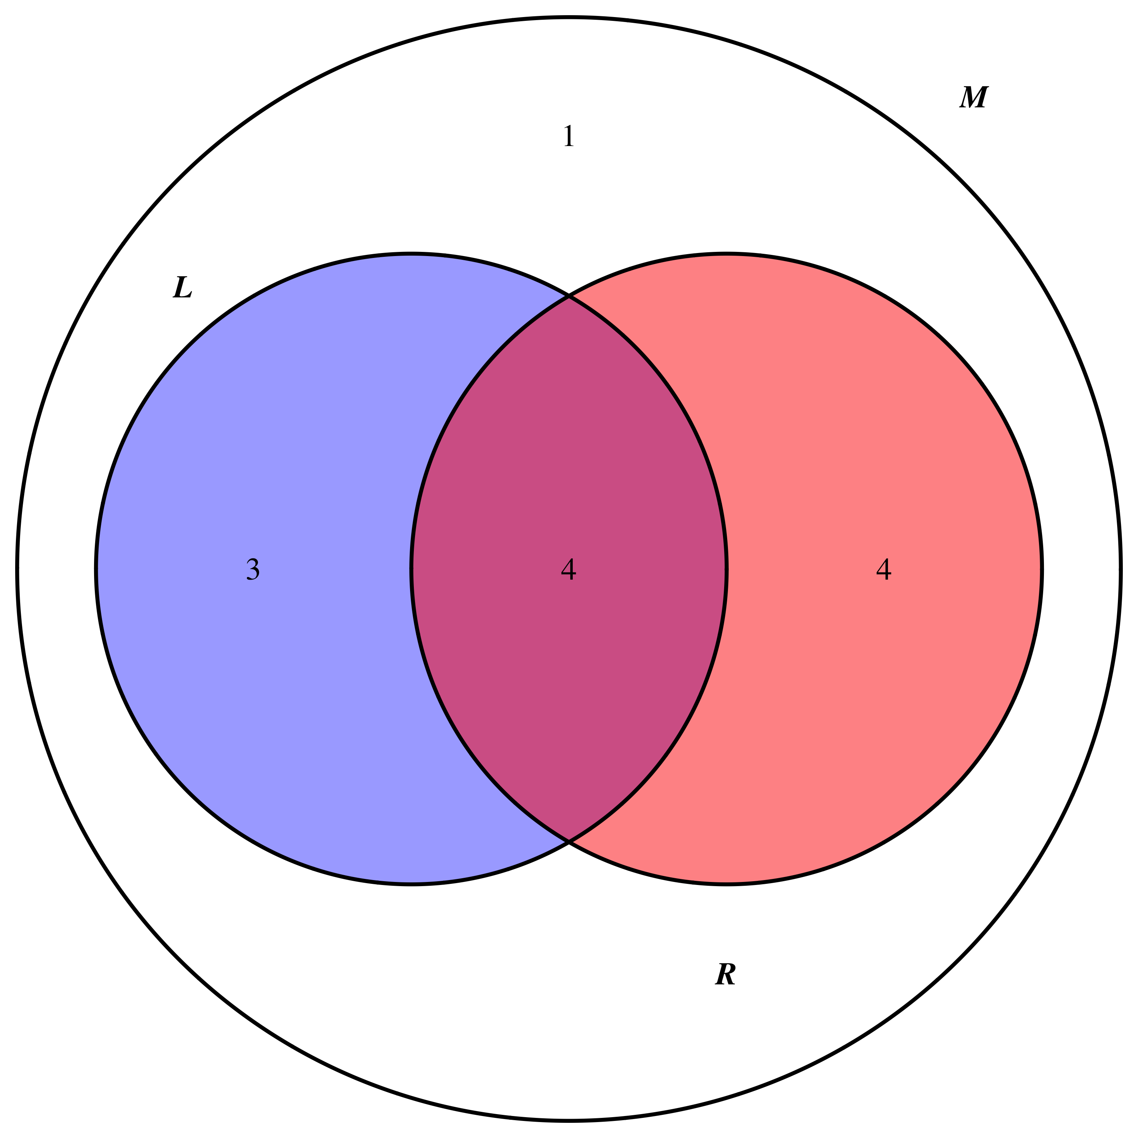

Problem 3:

a) shooting a single three-point shot:

> P3_1 = 0.358

b) shooting three free throws

> Pf_3 = 1 - pbinom(1, 3, 0.748) = 0.841

c) shooting a two-point field goal and a free throw

> P2f = 0.473 * 0.748 = 0.354

So the best chance is given by shooting three free throws

Problem 4:

a)

Boxplot of the data:

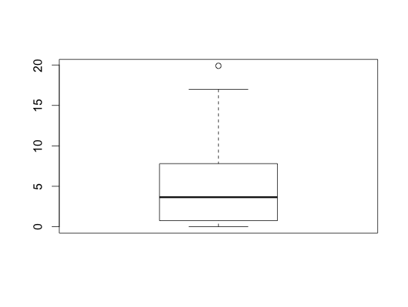

Summary of the data:

Min. 1st Qu. Median Mean 3rd Qu. Max.

0.000 0.775 3.650 4.688 7.700 19.900

Standard deviation of the data set: 4.81

Majority of the data are clustered around the median, which is 3.65, and there are a few points that are significantly larger than the rest.

b)

IQR = 7.7 – 0.775 = 6.925

According to the 1.5 * IQR rule, data that fall into this range is considered to be an outlier:

Value > 7.7 + 1.5 * 6.925 = 18.0875 or data value < 0.775 – 1.5 * 6.925 = -9.6125

After we rank the data, the outlier found is:

United States, with CO2 tons per person of 19.9

> CCO2[order(CCO2$CO2_tons_per_person, decreasing=T),]

Country CO2_tons_per_person

45 United States 19.9

3 Australia 17.0

6 Canada 16.0

37 Saudi Arabia 11.0

36 Russia 10.2

13 Germany 10.0

22 North Korea 9.7

Histogram:

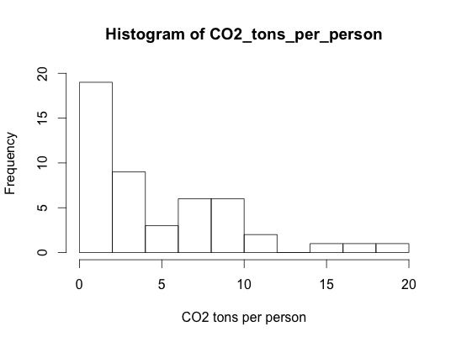

The rule suggests only taking US as an outlier, but it would also be a sensible decision if we include Australia(17.0) and Canada(16.0) as outliers as well.